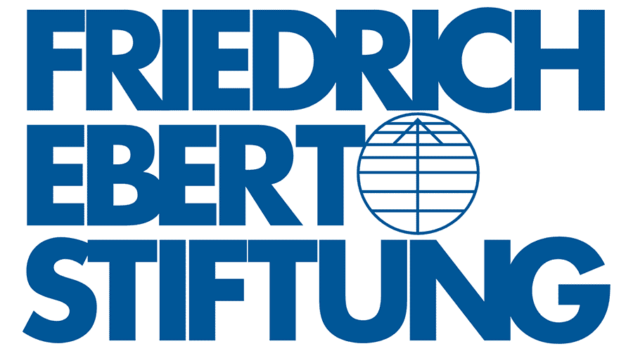

Progressive (FEPS-FES) Baltic Regional Meeting: Climate Justice in Europe: Policy and Strategy
Friday, March 18th, 2022: 14.00 – 18.15
Saturday March 19th, 2022: 9.00 – 12.00
Original Sokos Hotel Viru, Viru väljak 4, 10111 Tallinn
and via Zoom

The findings from 6th assessment report of the IPCC and the increased frequency of climate change related extreme weather events in Europe and the world have highlighted that a scaled up and rapid transition towards decarbonized economy is urgently needed on a global scale. In addition, other crucial environmental support systems are equally under threat with biodiversity loss, land degradation and the impact of chemical pollutants arriving at dangerous and in some cases irreversible levels. To address these issues at both the global and the European level a broad shift, which covers policies in energy and transport systems but also issues such as tax reforms, digitalization and regional and urban governance, is necessary. To ensure that such a shift can materialize and enjoy the support of the people that are meant to implement it, policies need to be designed and communicated in a way that foregrounds justice and fairness. The current spike in energy prices and its impact on energy poverty across Europe make this need for a just transition even more pressing. The meeting responds to the need to urgently develop and communicate a vision of just environmental and climate politics by bringing together researchers, progressive policymakers and foundations from the Nordic and Baltic regions and the European level.
Program

Friday March 18th, 2022
14:00 – 18:15: Thematic conference on just transition and climate justice in Europe (open, hybrid event)

14:00-14:30 Opening and registration

14:30-15:00 Welcome and introduction
Madis Roodla, International Secretary Social Democratic Party of Estonia
László Andor, Secretary General, FEPS

15:00-15:30 Keynote: Delivering a fair transition in difficult times
TBC

15:30-16:45 The European Green Deal: Implementation and Communication

Short Description:
The European Green Deal and the fit for 55 package constitute the strategy of the EU to become the first decarbonized continent and to switch economies and societies away from the unsustainable use of fossil fuels and other resources. These overarching policies are an opportunity to improve the quality of life and create a fairer economy for Europe’s citizens. However, the social implications of the ongoing energy crisis as well as more medium-term issues of the green transition like structural transformations in employment illustrate that both short- and long-term policies need to put questions of fairness and justice at the center stage. In addition to questions of policy design, progressives also need to be attentive to the narratives and frames they utilize to describe the green transition in order to not fall into the discourses pushed by those who want to stall climate action.

Key questions:
  - How to design policies that both decarbonize our economies and deliver progressive outcomes?
  - Does the EU green deal and the fit for 55 package take the social dimension sufficiently into account?
  - What should progressives emphasize when communicating about climate and the environment?

Chair: TBC

- Daniel Muth, Doctoral Researcher, Central European University
- Aleksandra Tomczak, Member of the Cabinet of Frans Timmermans, European Commission
- TBC
- Andrea Casamenti, Just Transition Policy Officer, European Alliance for a Just Transition

16:45-17:00 Coffee break

17:00-18:15 Managing regional and social impact for a just transition

Short description
While the EU climate targets apply to the entire Union, member states face different realities in their transitions. Moreover, within states s regional inequalities and disparities further nuance the picture. Taking such place-based differences into account when designing policies is thus imperative for a just transition. What is more, apart from acknowledging regional specificities paying attention to them can also facilitate exchanges and learning.

Key questions:
  - How can a green transition take place seriously and foster regional justice?
  - What can the Nordics and Baltics learn from each other in environmental and regional policies?
  - How can innovation policy be aligned with regional priorities?

Chair: TBC

- Kaisa Vattanen, Head of Policy and Planning SDP Finland
- Felicitas Sommer, Postdoctoral Researcher University of Halle
- Timo Karl, Policy Analyst, FES competence centre JustClimate
- Jevgeni Ossinovski, Sotsiaaldemokraatlik Erakond.

18:15-18:30 Concluding remarks
TBC

19:00 Dinner
Restaurant: Tallinn (TBC)
Dinner Speech: Representative of Estonian Social Democratic party

Saturday March 19th, 2022
9:30—12.00 Regional Coordination Meeting (closed-door, only in person participation)

9:30-9:35 Welcome
Madis Roodla, International Secretary Social Democratic Party of Estonia

9:35-10:45 Round table one: Perspectives for Social Democratic Parties, Foundations and Movements in the Baltic region

Short description
Background note: The developments of Social Democracy in transition contexts: Historical overview and forward-looking perspectives (TBC), followed by tour de table from participants discussing on common and divergent trends in the region

Moderation: Uwe Optenhögel, FEPS Vice-President

10:50-12:00 Round Table Two: Coordination and Common Projects between CEE Foundations and FEPS

Short description
Overview of activities for foundations in the FEPS framework.
Tour de table among participants providing assessments of the situations of their foundations.

Introduction and moderation: László Andor, Secretary General, FEPS
Overview of activities for foundations in the FEPS framework: David Rinaldi, Director, FEPS.

Refreshments and light lunch will be served after the event.
Departure

